Genetics Problems
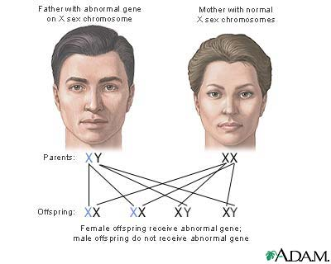
Monohybrid Crosses (Complete Dominance)
1. Match the following genotypes to their type --- MM, Mm, mm.
_____ Homozygous recessive _____ Hybrid
_____ Pure dominant _____ Pure recessive
_____ Heterozygous

2. In a certain plant, tall stems (T) are dominant to short stems (t). A farmer crosses a short-stemmed plant with a heterozygous long-stemmed plant. What are the expected genotypes, phenotypes, genotypic ratios, and phenotypic ratios? (Be sure to show how you got your answer --- Punnett Square!)
trait:
alleles:
cross: __________ X __________

genotypes _____________________
phenotypes ____________________
g. ratio _______________________
p. ratio _______________________
What TYPE of cross is this --- P1, F1, or F2? _______________

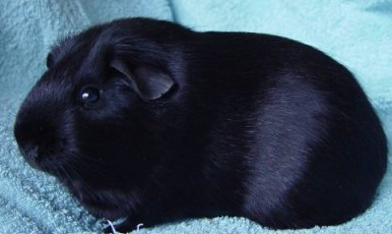3. The alleles for hair color in guinea pigs are brown (B) and white (b). Write the possible genotypes for hair color in guinea pigs and tell the phenotype for each.

GENOTYPES | PHENOTYPES
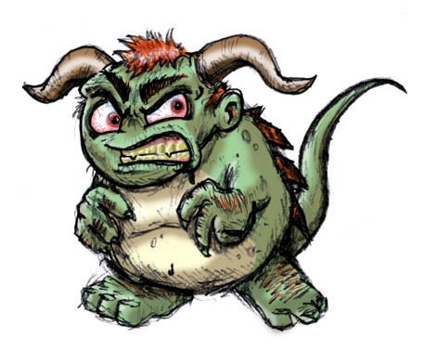4. Green is the dominant skin color for sea monsters (G), while yellow (g) is the recessive skin color. Show the results of crossing a homozygous green sea monster with a yellow sea monster.
trait:
alleles:
cross: __________ X __________

genotypes _____________________
phenotypes ____________________
g. ratio _______________________
p. ratio _______________________
What TYPE of cross is this --- P1, F1, or F2? _______________

5. Show the results of an F1 cross for the sea monster's offspring from question #4.
cross: __________ X __________

genotypes _____________________
phenotypes ____________________
g. ratio _______________________
p. ratio _______________________

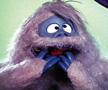6. In the hairy Blurp, purple fur (P) is dominant to pink fur (p). determine the genotypes, phenotypes, genotypic ratios, and phenotypic ratios for the following crosses:
A. Homozygous purple Blurp X Pink Blurp
trait:
alleles:
cross: __________ X __________

genotypes _____________________
phenotypes ____________________
g. ratio _______________________
p. ratio _______________________
What TYPE of cross is this --- P1, F1, or F2? _______________

B. Two heterozygous purple Blurps
trait:
alleles:
cross: __________ X __________

genotypes _____________________
phenotypes ____________________
g. ratio _______________________
p. ratio _______________________
What TYPE of cross is this --- P1, F1, or F2? _______________

C. Heterozygous purple Blurp X Pink Blurp
trait:
alleles:
cross: __________ X __________

genotypes _____________________
phenotypes ____________________
g. ratio _______________________
p. ratio _______________________
What TYPE of cross is this --- P1, F1, or F2? _______________

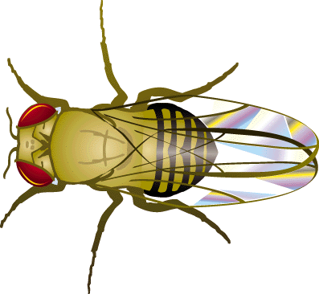7. In fruit flies, long wings (L) are dominant to short wings (l). Show the results of crossing:
A. Heterozygous long wing fly X Short winged fly
trait:
alleles:
cross: __________ X __________

genotypes _____________________
phenotypes ____________________
g. ratio _______________________
p. ratio _______________________
What TYPE of cross is this --- P1, F1, or F2? _______________

B. Two homozygous long wing flies
trait:
alleles:
cross: __________ X __________

genotypes _____________________
phenotypes ____________________
g. ratio _______________________
p. ratio _______________________

C. Homozygous long wing fly X short wing fly
trait:
alleles:
cross: __________ X __________

genotypes _____________________
phenotypes ____________________
g. ratio _______________________
p. ratio _______________________
What TYPE of cross is this --- P1, F1, or F2? _______________

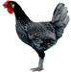8. In Andalusian fowl (fancy chicken), the gene for black plumage (feathers) is dominant (B). The allele (b) is recessive for white feathers. Show the results of a P1 and F1 cross for these chickens.

A. P1 Cross

trait:
alleles:
cross: __________ X __________

genotypes _____________________
phenotypes ____________________
g. ratio _______________________
p. ratio _______________________

B. F1 Cross
trait:
alleles:
cross: __________ X __________

genotypes _____________________
phenotypes ____________________
g. ratio _______________________
p. ratio _______________________

Complete Dominance Review
Using the trait flower position in garden peas, answer the following:
What are the 2 alleles?
What is the heterozygous genotype?
What phenotype does the hybrid genotype produce?
What is the homozygous recessive genotype for this trait?
What genotype(s) would result in terminal flowers?
What genotype(s) would result in axial flowers?

Monohybrid Crosses (Incomplete Dominance)
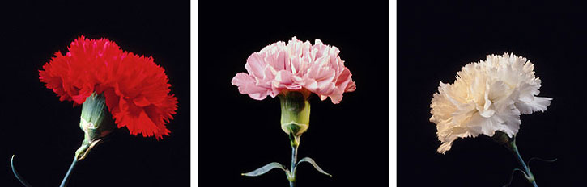9. The genes for flower color in carnations show incomplete dominance. In the hybrid genotype (Rr), the genes blend producing pink flowers. The homozygous dominant genotype produces red flowers (RR), while the homozygous recessive produces white flowers (rr). Show the results of crossing:
A. Pink flower X Pink Flower
trait:
alleles:
cross: __________ X __________

genotypes _____________________
phenotypes ____________________
g. ratio _______________________
p. ratio _______________________

B. White Flower X Red Flower
trait:
alleles:
cross: __________ X __________

genotypes _____________________
phenotypes ____________________
g. ratio _______________________
p. ratio _______________________

C. Red Flower X Pink Flower
trait:
alleles:
cross: __________ X __________

genotypes _____________________
phenotypes ____________________
g. ratio _______________________
p. ratio _______________________

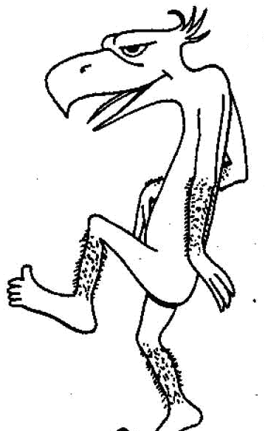10. Scientists recently found a new creature called a Birdnoid . It comes in three colors --- blue, red, and purple. This trait is controlled by a single gene with incomplete dominance. A homozygous (BB) individual is blue, a homozygous (bb) individual is red, and a heterozygous (Bb) individual is purple. Show the results of the following crosses:
A. Blue Birdnoid X Red Birdnoid
trait:
alleles:
cross: __________ X __________

genotypes _____________________
phenotypes ____________________
g. ratio _______________________
p. ratio _______________________

B. Two Purple Birdnoids
trait:
alleles:
cross: __________ X __________

genotypes _____________________
phenotypes ____________________
g. ratio _______________________
p. ratio _______________________

Incomplete Dominance Review
Using the same color trait found in Birdnoids, answer the following:
What is the heterozygous genotype?
What phenotype does the hybrid genotype produce?
What is the homozygous recessive genotype for this trait?
What genotype(s) would result in Blue Birdnoids?
What genotype(s) would result in Purple Birdnoids?
What genotype(s) would result in Red Birdnoids?

Codominance and Multiple Alleles
Human Blood type is determined by three alleles --- A, B, and O. Both A and B alleles are dominant, while O is recessive. Complete the following table for blood types and alleles.

Blood Types | Genotypes | Can DONATE TO: | Can RECEIVE Blood FROM:
A
B
AB
O

Show the results of the following crosses:
11. Father type AB blood X Mother with type O blood
cross: __________ X __________

genotypes _____________________
phenotypes ____________________
g. ratio _______________________
p. ratio _______________________

12. Both parents have type AB blood
cross: __________ X __________

genotypes _____________________
phenotypes ____________________
g. ratio _______________________
p. ratio _______________________

13. A. Could a couple have a child with type O blood if the mother is type B and the father is type A?___________
B. What would the genotypes of the parents have to be? ___________________
C. What is the probability of their having a child with type O blood? __________
D. What other genotypes could their children have? ______________________
E. If either or both of the parents were HOMOZYGOUS for type A or B blood, could they still have a child with type O blood? ____________

Sex-Linked Crosses
14. Hemophilia is a sex-linked trait where X^{H} gives normal blood clotting and is dominant to the hemophilia allele X^{h}.
A. Give the genotypes of a woman with normal blood clotting whose father had hemophilia

B. Give the genotypes of a normal man whose father had hemophilia

C. What is the probability that a mating between these two individuals will produce a child, regardless of sex, that has hemophilia?
trait:
alleles:
cross: __________ X __________

genotypes _____________________
phenotypes ____________________
g. ratio _______________________
p. ratio _______________________

D. If this couple has a daughter, what is the probability that the daughter will be a carrier of the hemophilia trait?

E. What is the probability a daughter would have hemophilia?

F. If this couple has a son, what is the probability he will have hemophilia?

15. A boy, whose parents and grandparents had normal vision, is color-blind, (X^{c}Y). What are the genotypes for his mother and his maternal grandparents. Use X^{C} for the dominant normal condition and X^{c} for the recessive, color-blind phenotype.
Mother___________ Grandfather___________ Grandmother__________
16. A woman with red-green color-blindness (X^{c}X^{c}) has a mother with normal vision (X^{C}X^{c}). Knowing that color-blindness is a sex-linked recessive gene, what is her father's phenotype is?
Dihybrid Crosses
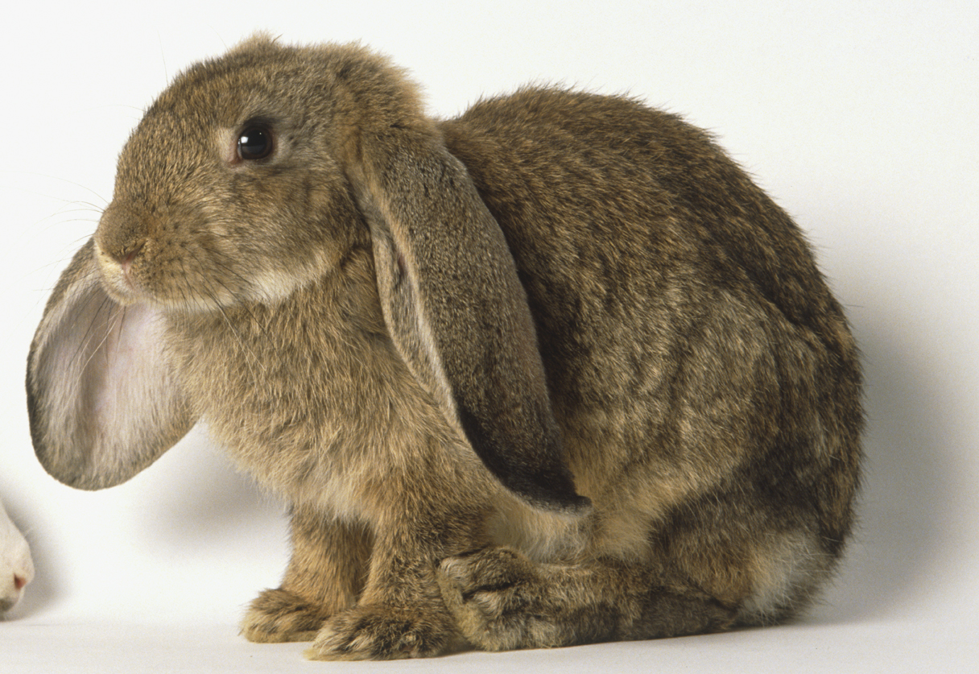17. In rabbits straight ears (SS) are dominant to floppy ears (ss) and brown fur is dominant (BB) to white fur (bb). Show the results of crossing:
A. Homozygous Straight-eared & Homozygous Brown Fur X Pure white, floppy eared rabbit
traits:
Alleles:

Cross: __________ X __________

B. Two heterozygous Straight-eared brown rabbits
traits:
Alleles:

Cross: __________ X __________

Genotypes Genotypic Ratio Phenotypes Phenotypic ratio

C. Heterozygous straight-eared & heterozygous brown fur X homozygous floppy-eared whit rabbit
traits:
Alleles:

Cross: __________ X __________
Genotypes Genotypic Ratio Phenotypes Phenotypic ratio

18. Carrion beetles lay their eggs in dead animals and then bury them in the ground until they hatch. Assume that the preference for fresh meat (F) is dominant to the preference for rotted meat and that the tendency to bury the meat shallow (S) is dominant to the tendency to bury the meat deep. Suppose a female carrion beetle homozygous dominant for both traits mates with a male homozygous recessive for both traits. What will be the genotype of the F₁ generation?

