NAME_________________________ DATE________ PERIOD_____
BACTERIA and VIRUSES
Bacteria
Using the terms and phrases provided below, complete the concept map showing the characteristics of bacteria.
bacillus peptidoglycan transformation
coccus toxins spirillum
conjugation transduction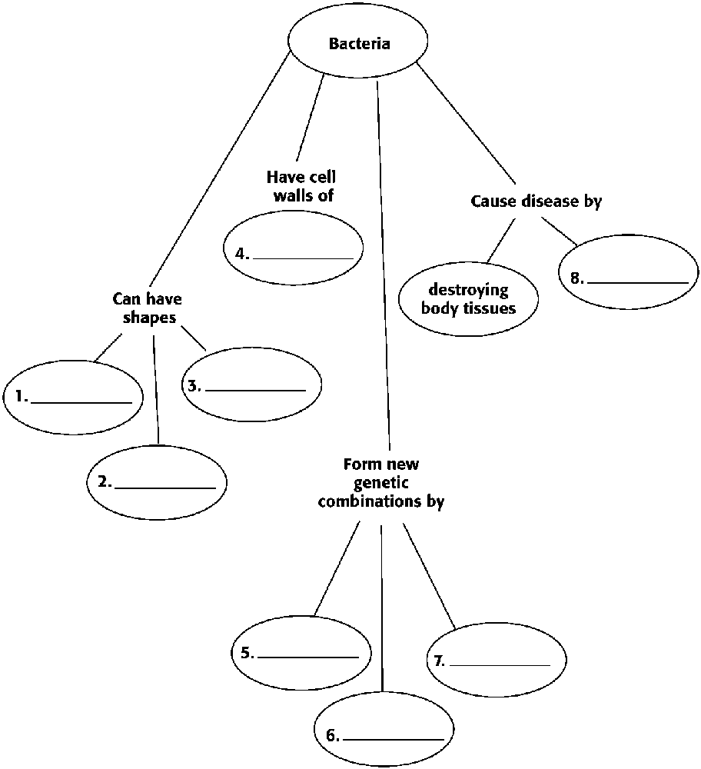
In the space provided, write the letter of the description that best matches the term or phrase.
a. short outgrowths that enable bacteria to attach to surfaces or to other cells
b. small extra loop of DNA
c. structure that allows a bacterium to survive harsh conditions
d. exchange of genetic material between two bacteria
e. a round-shaped bacterium
f. gets energy from other organisms
plasmid
coccus
pili
conjugation
endospore
heterotroph

In the space provided, write the letter of the term or phrase that best completes each statement or best answers each question.
Bacterial chromosomes consist of which of the following?
a. a single circular piece of DNA
b. linear pieces of DNA
c. DNA in paired chromosomes
d. DNA or RNA in various forms
All of the following are photoautotrophs except
a. Rhizobium.
b. cyanobacteria.
c. green sulfur bacteria.
d. purple sulfur bacteria.
The two major groups of prokaryotes are
a. heterotrophs and autotrophs.
b. Gram-positive and Gram-negative bacteria.
c. domain Bacillus and domain Coccus.
d. domain Archaea and domain Bacteria.
Gram-positive bacteria stain purple because they have
a. a thin layer of peptidoglycan in their cell wall.
b. a thick layer of peptidoglycan in their cell wall.
c. no peptidoglycan in their cell wall.
d. no cell wall.
In the space provided, write E if the characteristic describes only eukaryotes, B if the characteristic describes only bacteria, or EB if the characteristic describes both eukaryotes and bacteria.
have membrane-bound organelles
have ribosomes
can exist in the form of multicellular organisms
have a single chromosome called a nucleoid
reproduce by binary fission
have a cell wall made of peptidoglycan
have enzymes for performing metabolic activities
Complete each statement by underlining the correct term or phrase in the brackets.
Escherichia coli are [Gram-negative / Gram-positive] eubacteria.
[Conjugation / Transduction] is a process in which two bacteria exchange genetic material.
Escherichia coli have [pili and flagella / only flagella].
Many bacteria move with [flagella / pili].
In the space provided, write the name of the group—photoautotrophic, chemoautotrophic, or heterotrophic—to which each of the following types of bacteria belongs.
cyanobacteria
purple sulfur bacteria
bacteria that form their own proteins from hydrogen-rich chemicals
Rhizobium

* * * * * * *
Viruses
Read each question, and write your answer in the space provided.

What properties of life does a virus lack?

How do viruses reproduce?

What is the function of the tail and tail fibers in a phage?

In the space provided, write the letter of the description that best matches the term or phrase.
a. a protein with an attached carbohydrate molecule
b. the protein coat of a virus
c. a virus that infects bacteria
d. a membrane that surrounds the capsid of some viruses
capsid
envelope
glycoprotein
bacteriophage

In the space provided, write the letter of the term or phrase that best completes each statement or best answers each question.
Which of the following causes AIDS?
a. prion
b. HIV
c. bacteriophage
d. viroid
Viruses are not considered living because
a. they have no nucleic acids.
b. they do not metabolize.
c. they grow but cannot reproduce.
d. their cytoplasm doesn’t contain organelles.

The nucleic acid of a virus consists of which of the following?
a. DNA
b. RNA
c. both DNA and RNA
d. either DNA or RNA
The viral reproductive cycle that produces a provirus is a(n)
a. lytic cycle.
b. infectious cycle.
c. lysogenic cycle.
d. temperate cycle.
Interpreting Graphics
The figure below shows the lytic and lysogenic cycles. In the spaces provided, describe what is occurring in each numbered part of the figure.

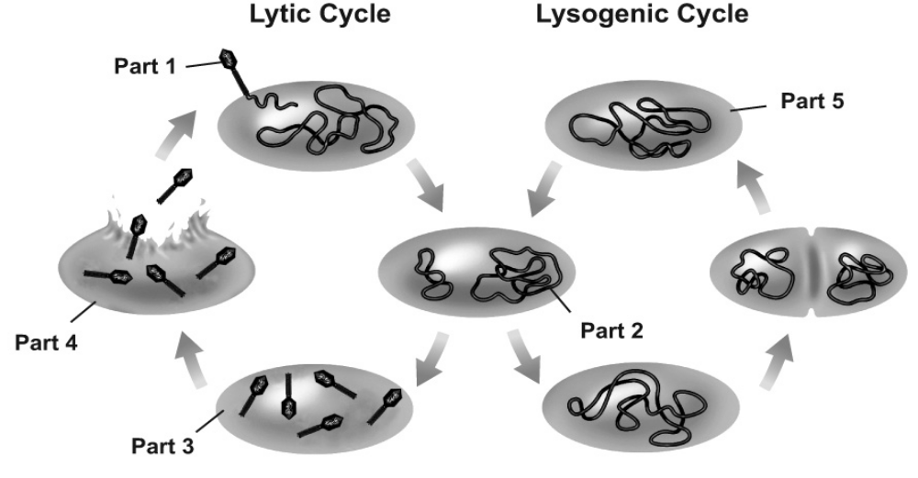
Part 1:

Part 2:

Part 3:

Part 4:

Part 5:

Work-Alikes
In the space provided, write the letter of the term or phrase that best describes how each numbered item functions.
virus envelope
a. copy machine
b. door key
c. a rumor being spread among people
d. a hypodermic needle
e. locking a door
f. bulletproof vest
bacteriophage
lytic cycle
vaccine
contagious disease
antibiotic resistance
Cause and Effect
In the space provided, write the letter of the term or phrase that best matches each cause or effect given below.

Cause
. viruses do not grow, do not maintain homeostasis, and do not metabolize
_________________
different receptors on cell surfaces
_________________
human papilloma virus
HIV
_________________
Clostridium tetani

Effect
____________________
host cell not destroyed
_________________
resistance to antibiotics
_________________
_________________
mad cow disease
_________________

a. prion
b. specificity of viruses
c. resistant bacteria survive and reproduce
d. AIDS
e. cervical cancer
f. they are not alive
g. lysogenic cycle
h. lockjaw

Linkages
In the spaces provided, write the letters of the two terms or phrases that are linked together by the term or phrase in the middle. The choices can be placed in any order.
_______bacteria_______
a. cell destruction in the lytic cycle
b. antibiotic resistance
c. produce toxins
d. unidentified bacteria
e. viral infection
f. conjugation
g. soil replenished with nitrogen compounds
h. Rhizobium bacteria
i. emerging disease
j. pathogens
k. new host organism
l. pink or purple stain
_______reproduction_______
_______bird flu_______
_______Gram staining_______
_______soybeans, beans, & peanuts_______
_______plasmid_______

Use the terms from the list below to fill in the blanks in the following passage.
bacteriophage envelope lytic
capsid lysogenic pathogen
The protein coat, or (1) __________________, of a virus may contain RNA or DNA, but not both. Many viruses have a(n) (2) _________________, which surrounds the capsid and helps the virus enter cells. Viruses that infect bacteria are called
(3) ______________________.
Any agent that causes disease is called a(n) (4) ______________________. Viruses cause damage when they reproduce inside cells many times. When the viruses break out, the cell is destroyed. The cycle of infection, reproduction, and cell destruction is called the (5) ______________________ cycle.
During an infection, some viruses stay inside the cells but do not make new viruses. Instead, the viral genes are inserted into the host chromosome. Whenever the cell divides, the viral genes also divide, resulting in two infected host cells. This type of replication cycle is called a(n) (6) ______________________ cycle.
In the blanks provided, fill in the letters of the term or phrase being described.
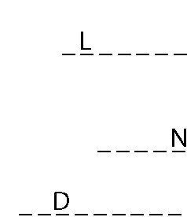
7. an extra loop of DNA that contains antibiotic-resistance genes

8. a poisonous chemical that is produced by bacteria

9. thick-walled structure that helps bacteria survive harsh conditions
In the space provided, write the letter of the description that best matches the term or phrase.
10. transduction
a. bacteria appear pink after staining
b. ability of a bacterium to tolerate antibiotics
c. process in which a virus transfers DNA from one bacterium to another
d. bacteria appear purple after staining
e. a guide for identifying specific pathogens
f. a process in which two organisms exchange genetic material
g. protein-carbohydrate compound found in bacterial cell walls
h. chemical that kills or inhibits the growth of bacteria
i. process in which bacteria take up DNA
fragments from their environment
11. peptidoglycan
12. Gram-positive
13. resistance
14. conjugation
15. transformation
16. Gram-negative
17. antibiotic
18. Koch’s postulates

