Making pH Indicators

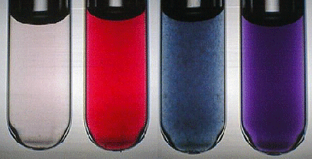

Introduction:

A pH indicator is a chemical compound that is added in small amounts to a solution so that the pH (acidity or alkalinity) of the solution can be determined easily. pH indicators are usually weak acids or bases themselves. They detect the presence of hydronium ions (H₃O⁺) or hydrogen ions (H⁺).

A procedure known as titration can be used to determine the presence of an acid or base. Titration uses the reaction between an acid and a base known as neutralization to determine the pH.
- A strong acid reacts with a strong base to form a neutral (pH=7) solution.
- A strong acid reacts with a weak base to form an acidic (pH<7) solution.
- A weak acid reacts with a strong base to form a basic (pH>7) solution.
Objective:
Students will create various pH indicators that can be used to test unknown solutions to determine if they are an acid or a base.
Time Required:
Two 55 minute periods
Materials per Group:
- Knife to slice veggies
- Measuring cup
- Hot plate
- Pan
- Two dropper bottles
- Electronic balance
- Distilled water
- Rubbing alcohol
- Red cabbage
- Fresh beet
- Laxative containing phenolphthalein
- Tumeric (dried spice)
- Coffee filters
- Bowl
- Cookie sheet
- Scissors
- Ziplock bags
- Measuring spoons
- Ammonia (unknown A)
- Vinegar (unknown B)
- Marking pencil
- pH indicator chart
- 4 small, clear plastic cups

Prelab:

Review safety procedures such as using caution when working with acidic and basic solutions since they can irritate the skin. Goggles and aprons must be worn throughout the experiment. All solutions can be washed down the drain with plenty of water.

Also review the pH scale. The scale goes from 0 to 14 with a pH of 7 being neutral. A pH from 0 up to 7 is acidic with 0 being the strongest acids. A pH above 7 to 14 would be basic or alkaline with 14 being the strongest base.

pH Indicator Chart

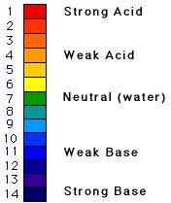

Procedure (Part A) – Making Natural Indicators:

Beet Juice Indicator Solution #1
Wash and slice a fresh beet. Place about four slices of beet into a pan containing one cup of water. Heat until boiling and continue boiling for about five minutes. Remove the beet slices and allow the red liquid to cool. Store juice in dropper bottles. Beet juice is red in acidic solutions and blue in basic solutions. Beets contain a pigment known as anthocyanin that will change from red to yellow somewhere between pH 11 and 12.
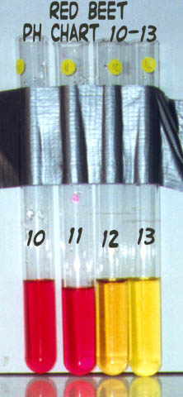

Phenolphthalein Indicator Solution #2
Purchase any laxative that contains phenolphthalein. With the back of a spoon, mash four to six tablets in a saucer. Pour the powder into a small cup. Add about ten milliliters of rubbing alcohol. Let this mixture stand for fifteen minutes. Pour off the liquid and store in a dropper bottle. Phenolphthalein is purple in very basic solutions and colorless in acidic solutions.

Turmeric Indicator Solution #3

Obtain a package of turmeric form the spice section of the grocery store. Add ¹/₄ teaspoon of turmeric to four tablespoons of rubbing alcohol. Stir to mix. Store in dropper bottle. Turmeric solution stays yellow in the presence of acids and changes to purple-brown in the presence of bases. Turmeric solution can also be made into indicator paper (see Cabbage Paper). Dry turmeric paper is bright yellow and changes to red in the presence of bases.

Red Cabbage Indicator #4
Tear five leaves of red cabbage into small pieces. Place the cabbage pieces in a small pan. Add four cups of hot water. Let the leaves soak for about half an hour until the water is a deep purple and cooled to room temperature. Strain the liquid into a storage bottle. Cover and store in the refrigerator. Red cabbage juice indicator is red in acid solutions, purple in neutral solutions, and greenish-yellow in basic solutions. Red cabbage contains a pigment molecule called flavin (an anthocyanin). This water-soluble pigment is also found in apple skin, plums, poppies, cornflowers, and grapes. Red cabbage juice will function over a wide pH range, from as low as pH 1 up to pH 12.
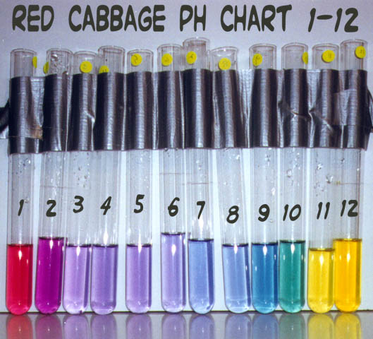

Cabbage Indicator Paper (optional)
Pour one cup of cabbage indicator (above) into a bowl. Dip one or two coffee filters into the indicator. Place the wet filter paper on a cookie sheet or flat pan. Continue to soak the paper until saturated. Allow the paper to dry (this will take more time than your class time, so use it the next day or for another activity). The paper will be pale blue. Cut the dry papers into strips about 1.25 by 7.5 centimeters (0.5 by 3 inches). Store the strips in a zip-lock plastic bag. Cabbage paper turns green in the presence of bases and pink to red in the presence of acids. NOTE: Beetroot indicator paper can be made in the same way.
Procedure (Part B) – Testing the Natural Indicators:
- Label two dropper bottles with UNKNOWN A on one and UNKNOWN B on the other.
- Fill each labeled dropper bottle with the correct unknown. These solutions will be used to test the indicators you made.
- Obtain 8 small, clear plastic cups. Label these 1A -4A and 1B – 4B for the indicator solutions you made.
- Correctly place a small amount of each indicator in the bottom of each labeled cup using the following table as a guide.
1A | 2A | 3A | 4A | 1B | 2B | 3B | 4B
Beet juice | phenolphthalein | Tumeric solution | Cabbage juice | Beet juice | phenolphthalein | Tumeric solution | Cabbage juice
- Record the name of the indicator and its initial color on the data table.
- Add one drop at a time of UNKNOWN A to the indicator in cup 1A. Record the unknown being used on the data table --- A or B.
- Stir with a toothpick or carefully swirl the cup after each drop.
- Continue adding one drop at a time followed by stirring until the color changes from the original color.
- Discard the toothpick and use a new toothpick for each indicator solution.
- Record the color change (final color) in the data table.
- Repeat steps 5 - 10 with each of the other indicators 2A – 4A.
- Using the color change information found in the recipe for the indicator, place a check mark in the Acid OR Base column on the data table for each of the color changes you found.
- Repeat steps 6 – 11 with cups 1B – 4B using UNKNOWN B.

Data and Results:
INDICATING ACIDS & BASES
Cup # | Unknown #  A or B? | Indicator Solution | Initial Color | Final Color | Acid? | Base?
1
2
3
4
5
6
7
8

Questions:
- When an acid and base combined what reaction results?
- What ion found in a solution would make it acidic?
- What scale is used to determine whether a solution is acidic or basic?
- A PH of less than 7 indicates the solution is a/an ___________________.
- A PH greater than 7 would indicate the solution was a/an _________________.
- A neutral Solution has a PH of _____.
- Beet juice indicator solution will be red in a/an_______.
- Beet juice indicator solution will be blue in a/an_________.
- Cabbage indicator solution will turn what color in the presence of bases
- Phenolphthalein indicator solution will turn what color in the presence of bases?
- Phenolphthalein indicator solution will turn what color in the presence of acids?
- Turmeric indicator solution stays yellow in the presence of acids and turns what color in the presence of bases?

Images: http://www.erowid.org/archive/rhodium/chemistry/equipment/ph-indicator.html

