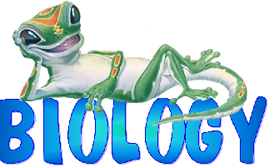 Name of Unit: Nature of Science - Safety Approximate Time: 4 days
Stage 1 Desired Results
ESTABLISHED GOALS:  Standards (Biology frameworks, Literacy common core, Math common core):  BIOLOGY:  NS.11. B.2 - Research and apply appropriate safety precautions (refer to ADE Guidelines) when designing and/or conducting scientific investigations.  LITERACY:  CCSS.ELA-Literacy.RST.9-10.3 Follow precisely a complex multistep procedure when carrying out experiments, taking measurements, or performing technical tasks, attending to special cases or exceptions defined in the text.  CCSS.ELA-Literacy.RST.9-10.4 Determine the meaning of symbols, key terms, and other domain-specific words and phrases as they are used in a specific scientific or technical context. |  | Transfer (BIG IDEA)
Students will be able to independently use their learning to…
Prevent accidents in the laboratory classroom, correctly handle safety equipment, and handle electrical, chemical and biological materials so they can relate home safety to lab safety and recognize good safety techniques.
 |  | Meaning
 |  | UNDERSTANDINGS (1-4)  Students will understand that…  - Proper safety techniques must be followed to insure the safety of themselves and others,  - All accidents regardless of how minor should be reported to your teacher |  | ESSENTIAL QUESTIONS (One for each understanding)  Students will keep considering…  - Why is safety important?  - What are some examples of lab accidents that you should report to your teacher?
 |  | Acquisition—What knowledge and skills will students learn?
 |  | Students will know: (Noun)  - Unsafe lab practices  - Location and proper usage of the  eyewash fountain, fire extinguisher, safety shower, etc.  - The main types of safety hazards-biological, electrical & chemical  - Proper procedures in the event of an emergency |  | Students will be skilled at: (Verb)  - Analyze a situation and determine poor safety techniques  - What are the school’s laboratory safety procedures in case of an accident?  - How would you revise an unsafe laboratory practice?  - Walk through proper procedures in the event of an emergency
Stage 2 – Evidence
Evaluative Criteria |  | Assessment Evidence—How will you determine if they’ve reached the goals of stage 1?
Lab Reports:  - Written Lab Report Instructions Handout  - Formal Lab Report Template  - Formal Lab Report Rubric  Lab reports will be graded for formatting scientific accuracy, and grammar |  | PERFORMANCE TASK(S):  FORMATIVE:  Student understanding will be periodically assessed using one of the following tools:  - Daily opener question  - Cold Call Questioning  - Group activity - Identification of SAFE and UNSAFE lab practices from a picture of students working in the lab  - Exit slips  SUMMATIVE:  - Demonstration of actual usage of equipment and following safety rules in the laboratory.  - A QUIZ over Lab safety and equipment.
Modifications for GT/IEP/504/ELL
- IEP/504 receive preferential seating, extended time, repetition of directions and explanations, and shortening of tests and assignments as needed
- ELL receive peer tutoring and grouping for labs and activities, both written and verbal directions, access to online translator, use of language dictionaries, and reduction in writing assignments if needed
- GT receive alternate, problem-solving labs and activities, statistical analysis of quantitative lab data using Chi-square and null hypotheses, movement through learning at their own pace (may work ahead, do additional research on topics, etc.)

Stage 3 – Learning Plan—Day by Day Plan/Activities to Reach the Goals
DAY | OBJECTIVE/OPENER/DUE | ACTIVITIES | MATERIALS/EQUIPMENT |  | ASSESSMENT
1 | OBJECTIVE  - TLW Research and apply appropriate safety precautions when designing and/or conducting scientific investigations  OPENER  - In the event of an accident or emergency in the lab, what is the FIRST thing you should do? | Activity #1  - Show PowerPoint on lab safety procedures, “Lab Safety”.  Closure/Homework  - Review safety procedures  - Exit Slip | 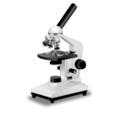  - Smart Board  - PowerPoint  - Exit slips  - Laptops  - Moodle |  | 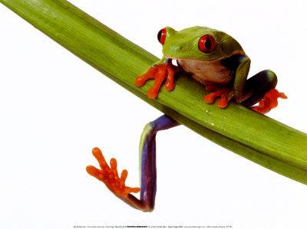  - Class Discussion  - Cold call questioning  - Exit slips
DAY | OBJECTIVE/OPENER/DUE | ACTIVITIES | MATERIALS/EQUIPMENT |  | ASSESSMENT
2 | OBJECTIVE  - TLW Research and apply appropriate safety precautions (refer to ADE Guidelines) when designing and/or conducting scientific investigations  OPENER  - How do you safely detect the odor of an unlabeled chemical in the lab? | Activity #1  - Continue showing PowerPoint on lab safety procedures, “Lab Safety”.  Closure/Homework  - Review safety procedures | - Smart Board  - PowerPoint  - Laptops  - Moodle |  | - Class Discussion
DAY | OBJECTIVE/OPENER/DUE | ACTIVITIES | MATERIALS/EQUIPMENT |  | ASSESSMENT
3 | OBJECTIVE  - TLW Research and apply appropriate safety precautions (refer to ADE Guidelines) when designing and/or conducting scientific investigations  OPENER  - What should be the FIRST thing you should do before starting a lab and the LAST thing to do when you are finished? | Activity #1  - Finish showing PowerPoint on lab safety procedures, “Lab Safety”.  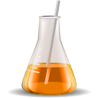Activity #2  - Working in a group, identify lab equipment and its function  Closure/Homework  - Go over equipment name & function | - Smart Board  - PowerPoint  - Beakers, graduated cylinders, flasks, mortar & pestle, thermometer, petri dish, microscope, electronic balance, dissecting pan and tools, etc.  - Laptops  - Moodle |  | - Correct identification and use for lab equipment
DAY | OBJECTIVE/OPENER/DUE | ACTIVITIES | MATERIALS/EQUIPMENT |  | ASSESSMENT
4 | OBJECTIVE  - TLW Research and apply appropriate safety precautions (refer to ADE Guidelines) when designing and/or conducting scientific investigations | Activity #1  - Students will move from station to station in the lab demonstrating proper safety procedures and use of equipment  Closure/Homework  - Study for Safety & Equipment Quiz | - Lab equipment set up at lab stations  - Lab safety devices (eye wash, shower, etc. with questions at each)  - Laptops  - Moodle |  | - Teacher Observation  - Class Participation

