ENERGY TRANSFER in BIOMES

For each biome, fill in arrows that trace the transfer of energy from the sun to a top predator. Label the producer(s) and each order consumer and color all parts of the chain.
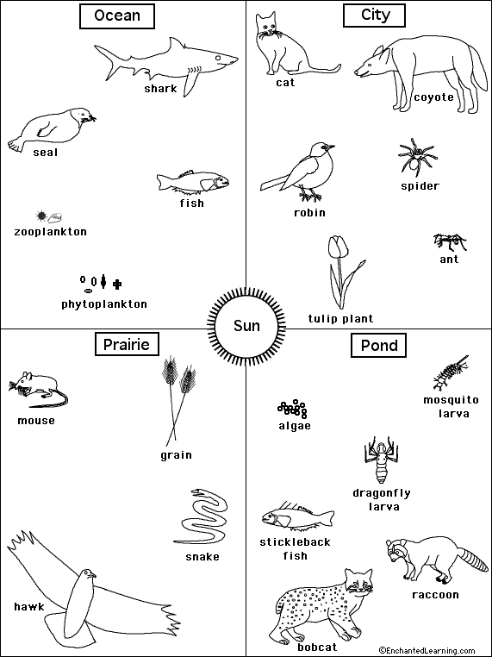

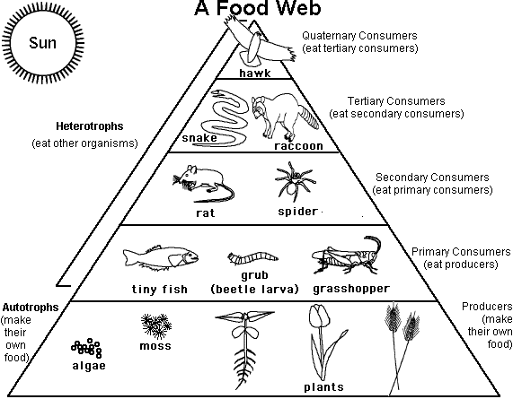

- There are many more __________________ than there are primary consumers.
- ________________ eat other organisms.
- _________________ make their own food so they are also called ____________.
- Where does the energy come from for all organisms in a food chain or web?
- Use algae and water plants as the producers and create a food web with 8 consumers.

Choose a freshwater ecosystem --- pond, stream, lake, wetland, bayou, etc. After choosing your ecosystem, put as many organisms as you can at each trophic level on the pyramid below.

ECOSYSTEM ___________________

