CELLULAR RESPIRATION

MULTIPLE CHOICE. Circle ALL that are TRUE. There may be more than one correct answer.

_______________________ is the first step in cellular respiration that begins releasing energy stored in glucose.
A. Alcoholic fermentation
B. Lactic acid fermentation
C. Glycolysis
D. Electron transport chain

The carriers for energy and high energy electrons during GLYCOLYSIS are ________.
A. ATP
B. NADH
C. FADH₂
D. NADPH

If oxygen is NOT present, glycolysis is followed by _____________________
A. Krebs cycle
B. electron transport chain
C. fermentation

Name the 3 carbon molecule produced when glucose is broken in half during glycolysis.
A. pyruvic acid
B. lactic acid
C. Acetyl-CoA
D. citric acid

Since fermentation does not require oxygen it is said to be __________________.
A. aerobic
B. anaerobic

Which high energy electron carrier is regenerated during fermentation that allows cells to continue to make ATP using glycolysis?
A. NAD⁺

B. NADPH
C. ATP
D. ADP

How many ATP molecules are added to get glycolysis started? _________

Since glycolysis produces 4 ATP molecules, this results in a NET GAIN of _____ ATP’s

MATCH THE LETTER IN THE DIAGRAM WITH THE LABEL:
(You can use them MORE THAN ONCE)
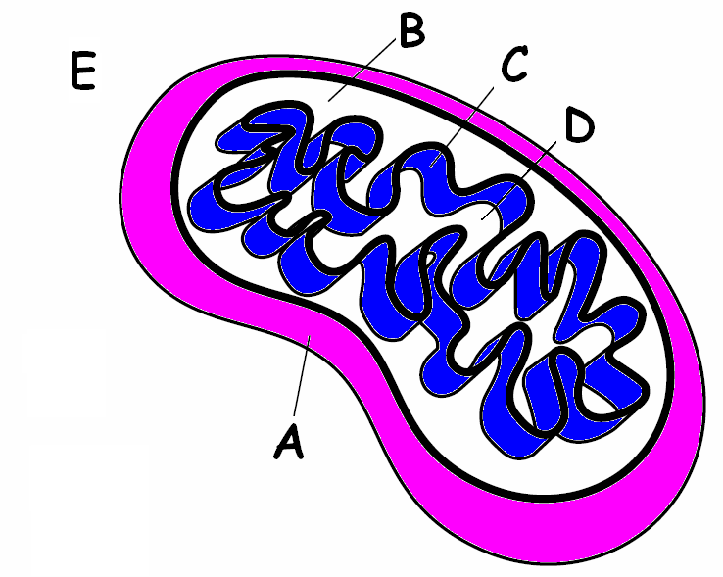
______ MATRIX

______ INTERMEMBRANE SPACE

______ CYTOPLASM

______ OUTER MEMBRANE

______ INNER MEMBRANE (CRISTAE)
______ Place GLYCOLYSIS happens

* * * * * * * * * * * * * *
Write the complete overall chemical equation for cellular respiration using chemical symbols instead of words:

____________ + _______________ → ________________+_________________+________________

Compare this reaction to the one you learned about last chapter for PHOTOSYNTHSIS
(6 H₂O + 6 CO₂ + light energy → C₆H₁₂O₆ + 6 O₂) How are these equations related?

_____________________________________________________________________

Write in words the equations for the two kind of fermentation:

Alcoholic fermentation
_________________+_______________→_________________+_________________ +______________

Lactic acid fermentation
___________________+_________________→___________________+_________________

* * * * * * * * * * * * * * *
Tell the kind of fermentation used in each example:
Yeast use this to make bread dough rise ________________________

Your muscle cells use this during rapid exercise when oxygen is low ________________

Bacteria and yeast use this to make beer and wine _____________________

Bacteria use this to make cheese, yogurt, and sour cream ___________________

If alcoholic fermentation is used to make bread dough rise, how come you don’t become intoxicated when you eat the bread?

_____________________________________________________________________
The Krebs Cycle and Electron Transport Chain

MULTIPLE CHOICE:
Circle the answer or answers that best complete the statement or answer the question.
(THERE MAY BE MORE THAN ONE RIGHT ANSWER.)

Which of the following shows the correct sequence during cellular respiration?
A. Electron transport chain → glycolysis → Krebs cycle
B. Glycolysis → Electron transport chain → Krebs cycle
C. Krebs cycle → Electron transport chain → glycolysis
D. Glycolysis → Krebs cycle → Electron transport chain

Where do the carbon atoms in pyruvic acid end up following the Krebs cycle?
A. They enter the electron transport chain and make ATP
B. They become part of a carbon dioxide molecule and end up in the atmosphere
C. They join with citric acid to make Acetyl-CoA
D. They build up in the intermembrane space

Because cellular respiration requires oxygen it is said to be _________________
A. aerobic
B. anaerobic

How many total ATP molecules are produced by 1 molecule of glucose completing cellular respiration ?

2 6 24 36

WHICH OF THE FOLLOWING ARE PRODUCED DURING THE KREBS CYCLE?
A. ATP
B. NADH
C. FADH₂
D. CO₂

What molecule is the final electron acceptor at the end of the Electron transport chain?
A. oxygen
B. carbon dioxide
C. glucose
D. NADH

The movement of which ion across the membrane from the intermembrane space to the matrix causes ATP synthase to spin and make ATP
A. Na⁺ ions
B. oxygen
C. H⁺ ions
D. water

Which stage of cellular respiration produces the most ATP?
A. glycolysis
B. Krebs cycle
C. Electron transport
D. Acetyl-CoA charging

Which of the following happens as electrons pass down the Electron Transport chain?
A. Energy from the moving electrons transports H⁺ ions into the intermembrane space
B. Carbon dioxide is released
C. Energy from H⁺ ions crossing back into the matrix causes ATP synthase to make ATP.
D. Water is produced

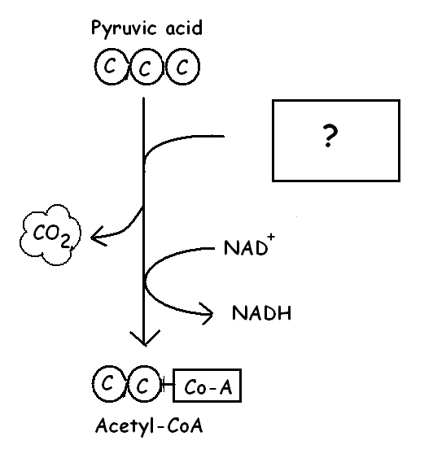
Name the ? molecule that joins in this reaction
to make Acetyl-CoA.
A. ATP
B. NADP⁺
C. Coenzyme A
D. citric acid

If oxygen is present, what will happen to the NADH produced in this reaction?
A. Its electrons will enter the Electron transport chain
B. It will donate its H⁺ ions to make glucose
C. It will join with ATP to make citric acid
D. It will join with oxygen to make CO₂

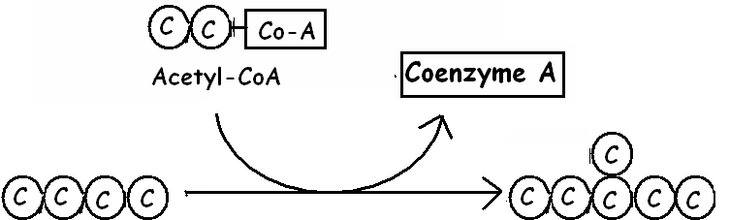

Name the 6 carbon molecule that forms when Acetyl-CoA joins its 2 carbons to a 4 carbon molecule during the Krebs cycle.
A. ATP
B. pyruvic acid
C. glucose
D. citric acid

MATCH THE LETTER IN THE DIAGRAM WITH THE LABEL:
(You can use them MORE THAN ONCE or NOT AT ALL)
______ Place where glycolysis happens

______ Place where enzymes for the Electron
Transport Chain are located

______ Place that fills with H⁺ ions as electrons move down the Electron transport chain
______ Place where ADP and P join to make ATP

______ Place where oxygen acts as the final electron
acceptor to make water

* * * * * * * * * * * * * * *

Explain why FADH₂ produces fewer ATP molecules than NADH when it passes its electrons down the Electron transport chain.

Explain where the enzymes for Electron Transport are located in bacteria (prokaryotes)
if they don’t have internal membranes.

* * * * * * * * * * * * * *

CELLULAR RESPIRATION VOCABULARY REVIEW

- __ __ __ __ __ __ __ __ __ __ is a 6 carbon molecule that is produced first when acetyl-CoA joins with a 4 carbon molecule to enter the Krebs cycle.

- __ __ __ __ __ __ __ __ __ __ is the process of splitting a glucose molecule into 2 pyruvic acid molecules.

- The molecule used by cells to store and transfer energy is __ __ __.

- Glycolysis happens outside the mitochondria in the __ __ __ __ __ __ __ __ __ of the cell.

- __ __ __ __ __ __ __ __ __ __ __ __ __ __ __ __ __ __ __ happens when oxygen is present and includes glycolysis, Krebs cycle, and Electron transport.

- This describes a process that requires oxygen = __ __ __ __ __ __ __

- This high energy electron carrier produces fewer ATP’s than NADH as its electrons pass through the Electron Transport Chain because it enters farther down the chain
  - =__ __ __ __ __

- This atmospheric gas is required for aerobic respiration = __ __ __ __ __ __.

- This describes a process that does NOT require oxygen; it means “without air”
  - = __ __ __ __ __ __ __ __ __

- Type of fermentation used by human muscles in low oxygen conditions and microorganisms to make yogurt, cheese, pickles, sauerkraut and kimchi. = __ __ __ __ __ __ __ __ __ __

- As electrons pass down the electron transport chain, H⁺ ions build up in the
  - __ __ __ __ __ __ __ __ __ __ __ __ __ space.

- The __ __ __ __ __ cycle breaks down pyruvic acid into carbon dioxide and produces NADH, FADH₂, and ATP.

- The NADH and FADH2 produced during the Krebs cycle pass their electrons down the
- __ __ __ __ __ __ __ __ __ __ __ __ __ __ __ __ __ chain to produce ATP.

- The passage of H⁺ ions through __ __ __ __ __ __ __ __ __ __ __ causes it to spin and produce ATP.

- This 3 carbon molecule is produced during glycolysis when glucose splits in half
  - = __ __ __ __ __ __ __ __ __ __ __

- Cell organelle which acts as the cell’s power plant to burn glucose and store energy as ATP
  - = __ __ __ __ __ __ __ __ __ __ __ __

- If oxygen is NOT present, glycolysis is followed by __ __ __ __ __ __ __ __ __ __ __ __.

- Type of fermentation used to make bread dough rise and produce beer and wine.
  - = __ __ __ __ __ __ __ __ __

- This molecule has the formula C₆H₁₂O₆ and is split in half during glycolysis = __ __ __ __ __ __ __

- The carbon atoms in pyruvic acid end up as __ __ __ in the atmosphere following the Krebs cycle.

- 9. The folded inner membranes inside a mitochondrion are called __ __ __ __ __ __ __.

- This molecule reacts with pyruvic acid to release C0₂, produce NADH, and acetyl-CoA.
  - = __ __ __ __ __ __ __ __ __

- __ __ __ __ __ __ __ __ __ forms when Coenzyme A attaches to two carbons from pyruvic acid.

- __ __ __ __ __ __ __ __ is the storage form of glucose used by animal cells which can be broken down for energy when glucose is used up.

- The area inside the cristae where the Krebs cycle happens is the __ __ __ __ __ __.

LABEL &/OR EXPLAIN EACH OF THE FOLLOWING DIAGRAMS:

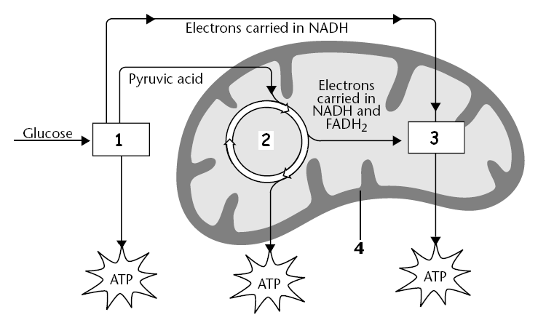

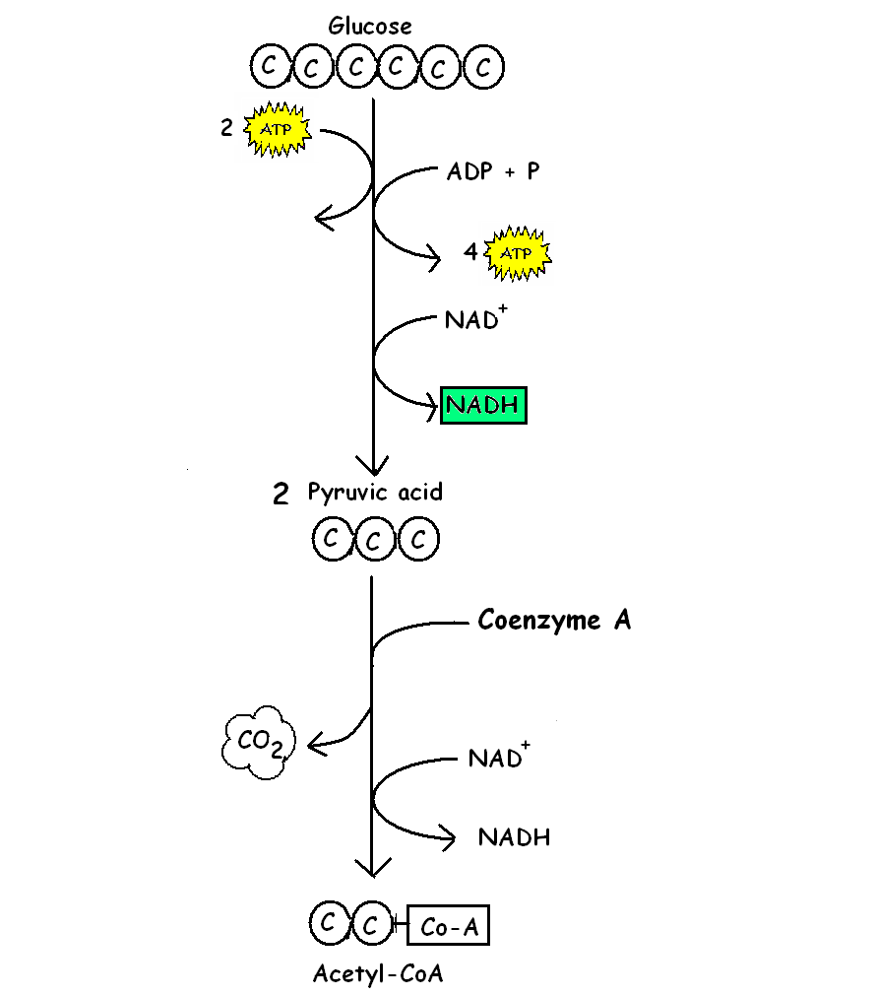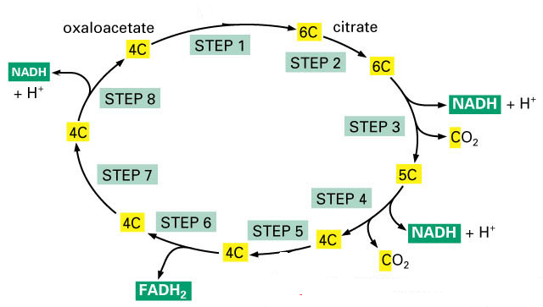
NADH + FADH₂
From Krebs ENTER
Name of Cycle?

Where Occurs?

What is made?
O₂ → ? + 36 ATP
Name of Process?
Where it occurs?
Gas used?
Substance made?
Net ATP?
Name of process?

Where it occurs?

What’s split?

Aerobic or anaerobic?

Net ATP made?
Where cycle occurs?

Aerobic or anaerobic?

Gas produced

Energy carriers made?

